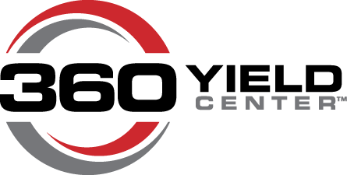
360 Yield Center :30 Second Announcer Read Radio Spots

360 SOILSCAN™ Radio Script
ANNOUNCER | What if you knew, in real time, how much nitrogen and pH was in your fields? You can. Three Sixty SOILSCAN is a portable testing system that delivers in-field soil nitrate and pH analysis in minutes. Call [insert dealer name], your local Three Sixty Yield Center dealer, at [insert dealer phone number] and stop guessing what’s left in your fields.

360 Y-DROP™ Radio Script
ANNOUNCER | What if you could apply nitrogen up until VT? You can. Three Sixty Y-DROP opens your application window as wide as V6 to VT, so you can apply N when it’s needed most. And precise application puts N within two to three inches of the stalk for maximum uptake. Call [insert dealer name], your local Three Sixty Yield Center dealer, at [insert dealer phone number] and widen your window of application.

360 UNDERCOVER™ Radio Script
ANNOUNCER | What if you could target plant health problems at the source? You can. Three Sixty UNDERCOVER provides targeted, under-canopy fungicide, insecticide and nutrient application for protection against late-season disease and insect infestation. Call [insert dealer name], your local Three Sixty Yield Center dealer, at [insert dealer phone number] and improve crop health with smarter application.

Nitrogen Management Radio Script
ANNOUNCER | Precision nitrogen management is about feeding your crop when it needs nitrogen most so you make the most of inputs for better performing crops and better on-farm profits. Three Sixty Yield Center gives you the power to know how much nitrogen you need and allows you to apply N all season with accuracy. Call [insert dealer name], your local Three Sixty Yield Center dealer, at [insert dealer phone number] for full-season nitrogen management tools.

360 CHAINROLL™ Radio Script
ANNOUNCER | What if you could use stalk residue to your advantage? You can. Three Sixty Chainroll is a new stalk roll that cuts stalks into 6-inch sections and scores them for faster microbial breakdown inside the stalk. So, you have better nitrogen availability with more manageable residue. Call [insert dealer name], your local Three Sixty Yield Center dealer, at [insert dealer phone number] to get your set today.

360 EQUI-FLOW™ Radio Script
ANNOUNCER | What if you could get precision anhydrous ammonia application even in cold temperatures? You can. The Three Sixty Equi-Flow NH3 Application System uses a gas separation method and pump pressure to keep anhydrous in liquid form for improved row-to-row accuracy. Call [insert dealer name], your local Three Sixty Yield Center dealer, at [insert dealer phone number] for precision nitrogen app year round.

